Problem Statement
A university offers several courses, and each course has its own rules: which subjects a student must have studied, the minimum marks in those subjects, an overall aggregate cutoff, and a fixed number of seats. Hundreds of candidates apply, and each wants one course. We must check every candidate against their course’s rules, rank the eligible ones, break ties with fixed criteria, and produce a ranked list showing who is admitted and who is waitlisted.

Objectives
- Store each course’s rules (required subjects, minimum marks, cutoff, seats).
- Check subject eligibility: the candidate must have studied each required subject and scored its minimum.
- Check the aggregate against the course-specific cutoff.
- Rank the eligible candidates of each course separately.
- Break ties using predefined criteria.
- Mark candidates as ADMITTED (within seats) or WAITLIST.
- Give a clear reason for every rejection.
Assumptions

Course | Required subjects (minimum marks) | Cutoff | Seats | Tie-break subject
CSE | Maths 60, Physics 50, English 40 | 70% | 3 | Maths
PHY | Maths 50, Physics 60 | 60% | 2 | Physics
COM | Accountancy 50, English 40 | 55% | 2 | Accountancy

Algorithm
- Define the course rules.
- Read the list of candidates.
- For each candidate:
  - If the course does not exist → invalid application.
  - For each required subject: if it is missing or below its minimum → reject with reason.
  - Compute the aggregate. If it is below the course cutoff → reject with reason.
  - Otherwise add the candidate to that course’s eligible list.
- For each course, sort its eligible list using the tie-break key.
- Assign ranks 1, 2, 3, …
- Rank ≤ seats → ADMITTED; otherwise → WAITLIST.
- Print the ranked list and rejection reasons for every course.
Pseudocode
COURSES = { code: required_subjects, cutoff, seats, primary_subject }

FUNCTION aggregate(marks):
RETURN sum(marks) / count(marks)

FUNCTION check_eligibility(candidate):
course = COURSES[candidate.course]
FOR each (subject, minimum) in course.required:
IF subject not in candidate.marks RETURN (False, "subject missing")
IF candidate.marks[subject] < minimum RETURN (False, "low subject mark")
IF aggregate(candidate.marks) < course.cutoff RETURN (False, "low aggregate")
RETURN (True, "")

FUNCTION ranking_key(candidate):
RETURN (-aggregate, -primary_subject_marks, -entrance, dob, name)

MAIN:
FOR each candidate:
IF candidate.course not in COURSES: mark invalid; CONTINUE
(ok, reason) = check_eligibility(candidate)
IF ok: add to eligible[course]
ELSE: add (candidate, reason) to rejected[course]
FOR each course:
SORT eligible[course] BY ranking_key
FOR rank = 1 to length(eligible[course]):
IF rank <= seats: status = "ADMITTED"
ELSE: status = "WAITLIST"
PRINT rank, candidate, status
PRINT rejected list
Test Cases
# | Candidate | Course | Key input | Expected result | Rule tested
1 | Eswar | CSE | Maths 55 (needs 60), aggregate 80 | Rejected: Maths 55 < 60 | Subject minimum
2 | Gopal | CSE | Physics not studied | Rejected: subject missing | Required subject
3 | Farah | CSE | Aggregate 65 (cutoff 70) | Rejected: aggregate | Course cutoff
4 | Jaya | PHY | Physics 55 (needs 60) | Rejected | Different course rules
5 | Lokesh | COM | Accountancy 45, aggregate 75 | Rejected: subject | Good aggregate cannot save a failed subject
6 | Meena | COM | Aggregate 51.67 (cutoff 55) | Rejected: aggregate | Cutoff per course
7 | Naveen | MBA | Course not in list | Invalid application | Unknown course
8 | Arun, Bhavna, Chetan, Deepa | CSE | All aggregate 80 | Order decided by tie-breaks | Tie resolution
9 | Bhavna vs Arun | CSE | Same aggregate and Maths; entrance 92 vs 88 | Bhavna first | Tie-break 3 (entrance)
10 | Deepa vs Arun | CSE | Same aggregate, Maths, entrance; DOB 2005-12-15 vs 2006-03-10 | Deepa first | Tie-break 4 (older)
11 | Chetan | CSE | Same aggregate, Maths 85 (lower) | Rank 4, waitlisted | Tie-break 2 (Maths) and seat limit
12 | Kavya | COM | Only one eligible for 2 seats | Admitted, no waitlist | Fewer eligible than seats

Output
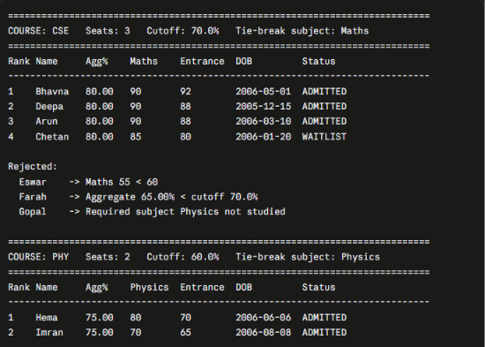

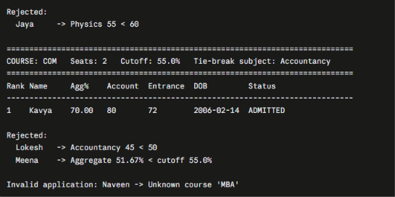
Flowchart
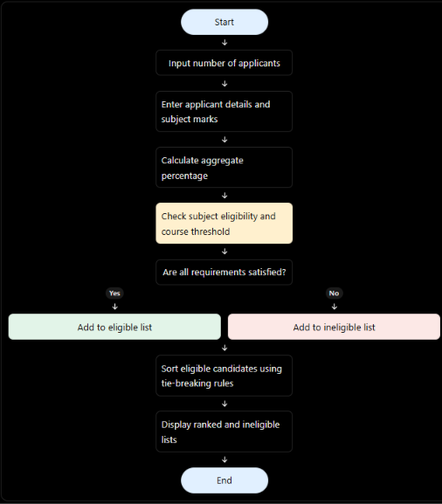
Conclusion
The engine applies each course’s own rules in a fixed order: subject eligibility first, then the aggregate cutoff. It then ranks the survivors and resolves ties through a clear chain of criteria. Because every rejection comes with a reason and every tie is settled by a documented rule, the process is transparent and repeatable. All course rules live in one COURSES dictionary, so a new course can be added by adding one entry, without changing any logic.

